A Project Report

On

**ISSUES IN LABOUR ECONOMICS**

BY

**SIDDARTH SURESH GOPALAKRISHNAN**

**2017B3A71379H**

Under the supervision of

**PROF. A BHEEMESHWAR REDDY**

**SUBMITTED IN PARTIAL FULFILMENT OF THE REQUIREMENTS OF**

**ECON F266: STUDY PROJECT**



**BIRLA INSTITUTE OF TECHNOLOGY AND SCIENCE PILANI (RAJASTHAN)**

**HYDERABAD CAMPUS**

**(JUNE 2020**)

**ACKNOWLEDGMENTS**

I am very grateful to Prof. Bheemeshwar Reddy for giving me this opportunity to work on a project that would help us analyse the issues present in the labour economy and for also helping and guiding me through the project work and also teaching me the necessary topics for a better understanding. I would also like to thank the economics faculty for providing their knowledge in this domain and helping me through the course of the project.



**Birla Institute of Technology and Science-Pilani,**

**Hyderabad Campus**

**Certificate**

This is to certify that the project report entitled “**Issues in Labour Economics”** submitted by Mr. Siddarth Suresh Gopalakrishnan (ID No. 2017B3A71379H) in partial fulfillment of the requirements of the course ECON F266, Study Project Course, embodies the work done by him under my supervision and guidance.

**Date: 29/06/2020 (A BHEEMESHWAR REDDY)**

BITS- Pilani, Hyderabad Campus

**ABSTRACT**

In this study project, we focus on the concepts of stratification and how it is different from the inequality measures. Although related, they represent different social aspects. Many economists and sociologists, to this day, still rely on inequality measures which don’t represent class stratification accurately. The boundary between stratification and inequality in their use in substantive research is hardly visible today. Since very few papers have talked about stratification in the Indian context, we would like to study the same and look at other possible unexplored topics.

**CONTENTS**

Title page………………………………………………………………………..…….1

Acknowledgements…………………………………………………….………….….2

Certificate…....………………………………….…….………………………...…….3

Abstract….…………………….……………………………………………………...4

1. Stratification vs Inequality.………….…….…………………….…….……….…...6

2. Why the study of stratification is important.……………………………………….7

3. Relevance in the Indian Context.…………………..……………………………….7

4. Prior studies in the Indian context…………..………….…………………….….…8 5. Data and Non-Parametric Index.…………….………….…………………….……9 6. Methodology and Results.…………………………….…………………….….…10 7. Conclusion………………………………………………………………………...14 8. Code……..………………………………………………………………………...15

References……………….………….……………………………………………….17

**STRATIFICATION vs INEQUALITY**

Stratification and inequality are two fundamental concepts in sociology and economics. Although related, they represent different social aspects. Inequality is a state in which social or economic resources are unevenly distributed across individuals or population sub-groups. Stratification, on the other hand, depicts how the population is divided into several hierarchical classes or ‘strata’. The two concepts are often used interchangeably, but it is essential to differentiate them to formulate effective policies.

Stratification is essentially a process of forming strata where each stratum has its characteristics. This results in a hierarchy of layers which, at a higher degree, may exacerbate the political and social consequences of inequality in the society. This distinction has been illustrated in the paper by Xiang Zhou on ‘Income Stratification among Occupational Classes’ which presented the concepts concerning the income distribution between blue-collar and white-collar workers in the USA as follows:

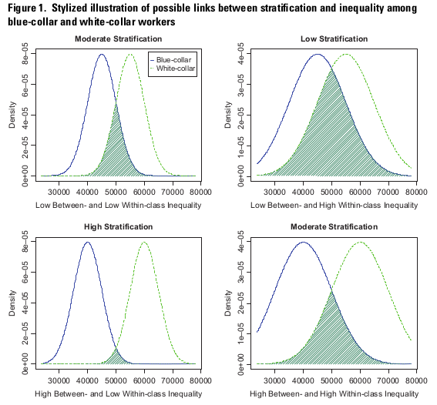

**WHY THE STUDY OF STRATIFICATION IS IMPORTANT**

The study of stratification is critical, while formulating policies aimed at reducing inter-class and intra-class inequality. Stratification may lead to social unrest and a divided political and social order in society. From an ethical standpoint, it is essential to find the impact of different classes on the stratified outcome as there is no reason for people belonging to particular strata to do better/worse than a person belonging to another stratum when they are given equal opportunities.

The study of stratification is essential, also, as it’s essential for analysing different occupational classes and their impact on income distribution. The concepts such as “death of class”, “decomposition of class” and “resurrection of class” have been analysed by Zhou in the paper on Income Stratification which highlights the trends in occupational class stratification and micro class stratification.

Despite stratification being crucial to the study of class structure, many economists and sociologists still rely on inequality measures which don’t represent class stratification accurately. The boundary between stratification and inequality in their use in substantive research is hardly visible today.

Thus, both stratification and inequality are important concepts to be analysed before taking any policy decision, and above are a few reasons why we must not rely solely on inequality measures.

**RELEVANCE IN THE INDIAN CONTEXT**

India is a society where social structures such as the caste system and religion are still prevalent to this day. Stratification is important in the Indian context as it will be crucial to analyse the impact of the caste system, religion and other such societal hierarchies on the income earned by people belonging to each class.

An example of stratification based on the caste system is the division into four categories, namely, Brahmin, Kshatriya, Vaishya and Shudras, where each category has its sub-categories. A study of stratification could result in efficient methods of reducing the inter-caste and even the intra-caste differences. Other examples of social classes present in India are religion, gender, income classes (upper, middle or lower class), etc.

Another important reason to study stratification is to reduce the differences between various occupational classes and micro classes in India. Some examples of classes could be professional-managerial employees, proprietors, non-farm manual workers and some examples of micro classes could be health professionals, professors, managers, etc. who fall under some categories of meso-classes.

Thus, it is important to study stratification, especially in the Indian context, as it will help us understand the hierarchy of the occupational groups and sub-groups which in turn will help us take measures to reduce the differences that exist between these groups to ensure equality in opportunity.

**PRIOR STUDIES IN THE INDIAN CONTEXT**

There have been a few studies which focussed on the class and caste system in India and have also analysed the stratification along with inequality.

There is a paper which touches on social stratification from the gender perspective, i.e., the paper by Reshma Elizabeth Thomas on ‘Gender Inequality in Modern India’ which primarily focusses on gender inequality in India but also highlights how the income distribution is differentiated for males and females in India.

There are a few papers which analyse income stratification in India from the class and caste perspective. For example, the paper titled ‘Caste Stratification and Wealth Inequality in India’ talks about the relationship between wealth inequality and caste divisions in India. Along with the extent of overlap between classes, the paper also suggests that the disadvantageous groups have lower average wealth than the other forward castes and the OBC and non-Hindus lie in the middle strata.

Another paper titled ‘Does Class Matter? Class Structure and Worsening Inequality in India’ talks about classes such as, urban elites (owners, managers), rural rentier classes (moneylenders, landlords) who are stratified to the top whereas the unskilled workers and marginal farmers are stratified to the bottom of the distribution. Previous studies provide information about inequality at a broad level, but it doesn’t tell us anything about how these groups are becoming relatively better off or worse off. These details are important as they tell us whether class structure matters and whether some classes have been excluded from the growth process or not.

**DATA AND NON-PARAMETRIC INDEX**

In this project we tried to analyse how the stratification index varied for indices with respect to different parameters between 2002 and 2013. In order to do this, we used a non-parametric index of stratification by Xiang Zhou as presented in his paper ‘A Nonparametric Index of Stratification (2012)’.

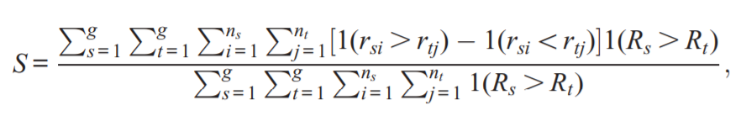

The above formula considers multiple groups with a population of ‘n’ subjects who belong to ‘g’ mutually exclusive groups. ‘ysi’ is the income of the ith member of the sth group. The income of all the subjects are sorted in ascending order and ‘rsi’ is the income rank corresponding to ysi. Then, the groups are ordered in increasing order of their average ranks and R is used to represent average rank of a particular group. Therefore, ‘r’ and ‘R’ give two sets of income ranks (one for individual observations and other for the subgroups). If the value of S obtained is ‘x’, then the result can be interpreted as the probability that a random individual, chosen from the higher ranked group, will have a higher income than the random individual chosen from the lower ranked group is equal to 0.5*(1+x).

There are certain advantages in using this index instead of a parametric index such as this index uses the ranks of different groups and doesn’t involve the within-group variation magnitudes. This index is independent of any rank preserving transformations and calculates the stratification measure for the entire population rather than a certain group.

In order to analyse the stratification in the Indian context, we collected the NSS wealth data of 2002 and 2013 from the National Data Archive. We have observed the difference between the stratification index between 2002 and 2013 with respect to various parameters such as religious groups, social groups, rural and urban population and also state-wise.

In order to implement the stratification index proposed by Zhou(2012), we have made use of the ‘strat’ package in R. This package provides two functions, ‘srank’, which calculates the stratum-specific average percentile rank and population share; and ‘strat’ which returns the stratification index and the standard error.

**METHODOLOGY AND RESULTS**

We have calculated the wealth stratification index with respect to different parameters in 2002 as well as 2013 and compared the index.

**Social Groups:**

There are four categories of social groups in our dataset namely,

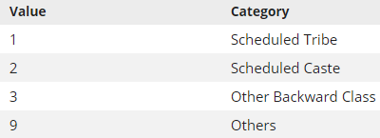

In order to get the stratification index with respect to the social groups, we used the following commands:

> # Social group

> s02_social = with(df2002, strat(pc_hh_net_wealth, B3_q6,weights = Weight))

> s13_social = with(df2013, strat(pc_hh_net_wealth, b3q7,weights = Weight_SC))

The outputs are as follows:

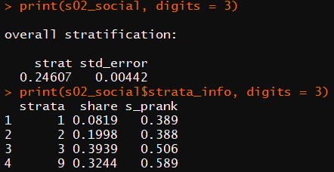 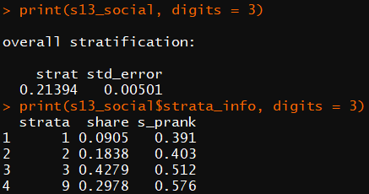

Therefore, from the output we can observe that in 2002, the stratification index with respect to social groups was 0.24607 and, in 2013, was 0.21394 which clearly indicates that the wealth stratification from 2002 to 2013 with respect to social groups in India has decreased.

**Religious Groups:**

In our dataset we had 8 categories of religious groups, namely,

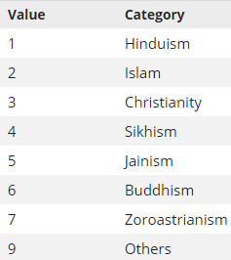

For index with respect to religious groups, we ran the following command:

> # Religion

> s02_religion = with(df2002, strat(pc_hh_net_wealth, B3_q5,weights = Weight))

> s13_religion = with(df2013, strat(pc_hh_net_wealth, b3q6,weights= Weight_SC))

And the outputs are as follows:

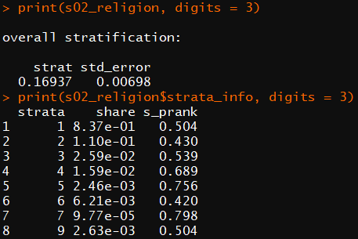 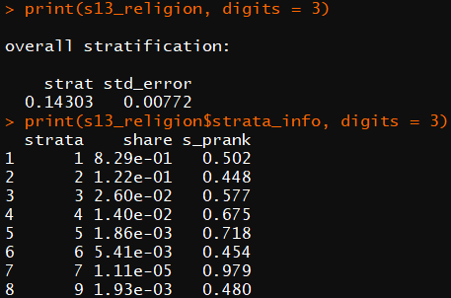

Here too we can observe that the wealth stratification index with respect to religious groups in India has decreased slightly from 0.16937 in 2002, to 0.14303 in 2013.

**Rural/Urban Regions:**

For analysing the index with respect to Rural and Urban regions:

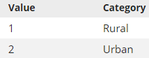

> # Rural-Urban

> s02_sector = with(df2002, strat(pc_hh_net_wealth, Sector,weights = Weight))

> s13_sector = with(df2013, strat(pc_hh_net_wealth, Sector,weights= Weight_SC))

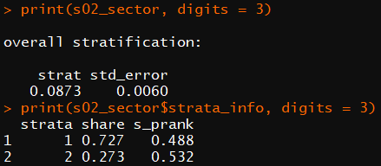 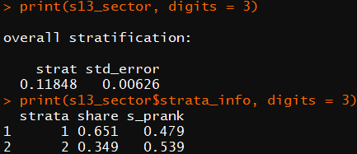

For the case of rural and urban stratification, we can observe that the index increases from 0.0873 in 2002 to 0.11848 in 2013 which implies that a randomly selected person from the urban population will have more wealth than a randomly selected person from the rural population with a 56% probability.

**State-wise Rural/Urban:**

We also calculated the wealth stratification index for each state in India with respect to rural and urban population for 2002 and 2013.

> # State-wise Rural/Urban

> dat_list_02 = split(df2002, df2002$State)

> dat_list_13 = split(df2013, df2013$State)

> sru1 = map(dat_list_02, ~with(.x, strat(pc_hh_net_wealth, Sector, weights = Weight)))

> sru2 = map(dat_list_13, ~with(.x, strat(pc_hh_net_wealth, Sector, weights = Weight_SC)))

The list of states and their corresponding index in 2002 and 2013 are as follows:

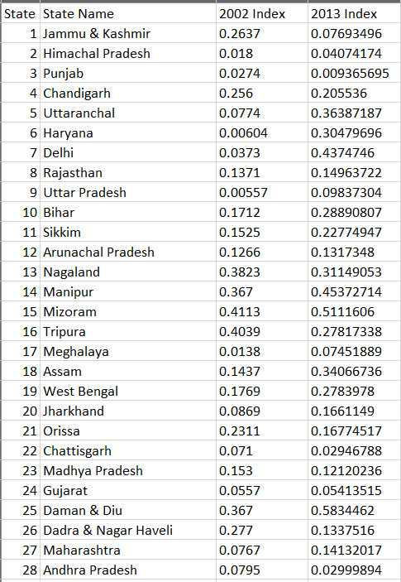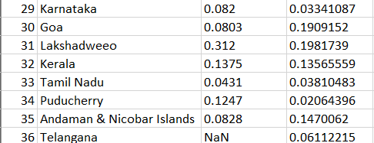

Therefore, we can see that for some states such as Jammu & Kashmir, the wealth stratification with respect to rural and urban population has decreased whereas for states such as Delhi, Maharashtra and Haryana, it has increased significantly.

**CONCLUSION**

There are various topics which could be covered such as the stratification with respect to primary, secondary and higher education amongst different castes and classes in order to observe whether the implemented policies by the government are indeed providing equal opportunities regardless of their caste or class. In the USA, despite efforts being made to reduce the income stratification between the blacks and the whites due to racial discrimination, there is still some income gap between them. According to a study, the decrease in family income rank disparity was followed by a shift in income distribution which turned out to help the rich more than the middle class and the poorer sections of the society. As black people were a majority in the middle and poor class, they weren’t benefitted from the distribution of income. With such analysis, we could also conduct a similar study in India.

And more importantly, it is essential to reduce the income stratification in India based on gender. Reduction in wage inequality and stratification, which is prominent in India, with respect to gender and caste is crucial for the overall social and economic development of the society.

Thus, in conclusion, we learnt about stratification and its importance, especially with respect to the Indian context. We also differentiated between stratification and inequality as they represent different social aspects many economists and sociologists, to this day, still rely on inequality measures which don’t represent class stratification accurately. As part of the study in the Indian context, we tried to analyse the variation in the wealth stratification index with respect to variables such as religion, social group, rural/urban region and also performed the analysis for each state for 2002 and 2013. The data on which we performed the analysis doesn’t include the billionaires list due to which this might not be an accurate representation of the different strata groups

**CODE**

|  |
| --- |
| # Loading the libraries  library(haven)  library(strat)  library(purrr)  # Importing the datasets  df2002 <- read_dta('E:/STUFF/3-2/ECON F266 PROJECT/wealth_data_2002R.dta')  df2013 <- read_dta('E:/STUFF/3-2/ECON F266 PROJECT/wealth_data_2013R.dta')  # Social group  s02_social = with(df2002, strat(pc_hh_net_wealth, B3_q6,weights = Weight))  s13_social = with(df2013, strat(pc_hh_net_wealth, b3q7,weights = Weight_SC))  print(s02_social, digits = 3)  print(s02_social$strata_info, digits = 3)  print(s13_social, digits = 3)  print(s13_social$strata_info, digits = 3)  # Religion  s02_religion = with(df2002, strat(pc_hh_net_wealth, B3_q5,weights = Weight))  s13_religion = with(df2013, strat(pc_hh_net_wealth, b3q6,weights = Weight_SC))  print(s02_religion, digits = 3)  print(s02_religion$strata_info, digits = 3)  print(s13_religion, digits = 3)  print(s13_religion$strata_info, digits = 3)  # Rural-Urban  s02_sector = with(df2002, strat(pc_hh_net_wealth, Sector,weights = Weight))  s13_sector = with(df2013, strat(pc_hh_net_wealth, Sector,weights = Weight_SC))  print(s02_sector, digits = 3)  print(s02_sector$strata_info, digits = 3)  print(s13_sector, digits = 3)  print(s13_sector$strata_info, digits = 3)  # State-wise Rural/Urban  dat_list_02 = split(df2002, df2002$State)  dat_list_13 = split(df2013, df2013$State)  sru1 = map(dat_list_02, ~with(.x, strat(pc_hh_net_wealth, Sector, weights = Weight)))  sru2 = map(dat_list_13, ~with(.x, strat(pc_hh_net_wealth, Sector, weights = Weight_SC)))  sru1  sru2 |

**REFERENCES**

* <http://www.iosrjournals.org/iosr-jhss/papers/Vol13-issue3/G01334850.pdf?id=3394>: Gender Inequality In Modern India–Scenario and Solutions; by Reshma Elizabeth Thomas.
* <https://www.brookings.edu/research/gender-issues-in-india-an-amalgamation-of-research/>: Gender issues in India: an amalgamation of research.
* <https://www.sciencedirect.com/science/article/pii/S0305750X11000969?via%3Dihub>: Caste Stratification and Wealth Inequality in India by Ajit Zacharias and Vamsi Vakulabharanam.
* <http://www.ijhssi.org/papers/v2(12)/Version-1/H021201057066.pdf>: Revisiting Social Stratification In Indian Society: A Review and Analysis with Focus on Kashmiri Society by Irshad, Ahrar and Zuber.
* <https://www.researchgate.net/publication/333560917_Class_caste_and_social_stratification_in_india_Weberian_legacy>: Class, caste, and social stratification in India.
* <http://www.iosrjournals.org/iosr-jhss/papers/Vol20-issue3/Version-8/F020382829.pdf>: Social Stratification in India by Prakhar Bisht.
* <https://papers.ssrn.com/sol3/papers.cfm?abstract_id=2067936>: Caste System and Social Stratification in India by Rahul Tiwari.

* <https://www.researchgate.net/publication/258188372_A_Nonparametric_Index_of_Stratification>: A Nonparametric Index of Stratification by Xiang Zhou.

* <https://scholar.harvard.edu/files/xzhou/files/zhou-wodtke2019_strat.pdf>: Income Stratiﬁcation among Occupational Classes in the United States by Xiang Zhou and T. Wodtke.